AIML SESSION 05 ASSIGNMENT SUBMISSION

Name of student: Vaibhav Vijay Kate
Domain/subject name: AIML (Artificial Intelligence & Machine Learning)
College and Branch name: Government Polytechnic College Washim (IF)
Q1. (String Indexing)
Write a program that takes a string input from the user.
Print:
- The first character
- Code:The last character (using negative index)
- The 3rd character from the start
- The 2nd character from the end
Add comments explaining positive and negative indexing.
Program Code:
#Take a string input from the user
name=input("Enter a string: ")

#The first character of the string can be accessed using index 0 (positive indexing)
print("The first character is:", name[0])

#The last character of the string can be accessed using index -1 (negative indexing)
print("The last character is:", name[-1])

#The 3rd character from the start can be accessed using index 2 (positive indexing)
print("The 3rd character from the start is:", name[2])

#The 2nd character from the end can be accessed using index -2 (negative indexing)
print("The 2nd character from the end is:", name[-2])

Output Screenshot:
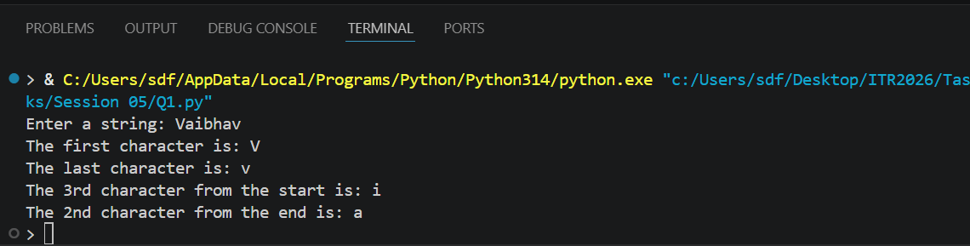

Q2. (String Slicing)
Take a string input from the user.
Using slicing, print:
a) The first 5 characters
b) The last 4 characters
c) The string in reverse order
d) Every 2nd character of the string
Include comments explaining the slicing syntax [start:end:step].
Program Code:
# Take a string input from the user
name = input("Enter a String:")

# a) The first 5 characters can be accessed using slicing with start index 0 and end index 5 (exclusive)
print("The first 5 characters are:", name[0:5])

# b) The last 4 characters can be accessed using slicing with start index -4 and end index as the length of the string (exclusive)
print("last 4 characters are:", name[-4:])

# c) The string in reverse order can be accessed using slicing with start index as the length of the string, end index as -1 (exclusive), and step as -1 (to reverse the string)
print("The string in reverse order is:", name[::-1])

# d) Every 2nd character of the string can be accessed using slicing with start index 0, end index as the length of the string (exclusive), and step as 2 (to skip every 2nd character)
print("Every 2nd character of the string is:", name[0::2])

Output Screenshot :
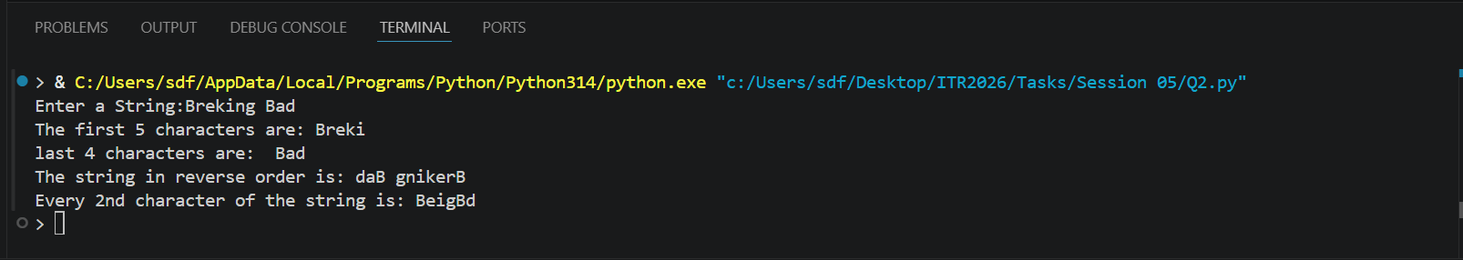

Q3. (String Membership)
Write a program that:
- Takes a main string and a substring as input from the user.
- Checks whether the substring is present in the main string using in and not in.
- Prints appropriate messages (e.g., "Substring found!" or "Substring not found!").
- Note that it is case-sensitive.
Program Code:
# Take a main string input from the user
main_string = input("Enter the main string: ")

# Take a substring input from the user
substring = input("Enter the substring: ")

# Check if the substring is present in the main string
if substring in main_string:
print("Substring found!")
else:
print("Substring not found!")

Output Screenshot :
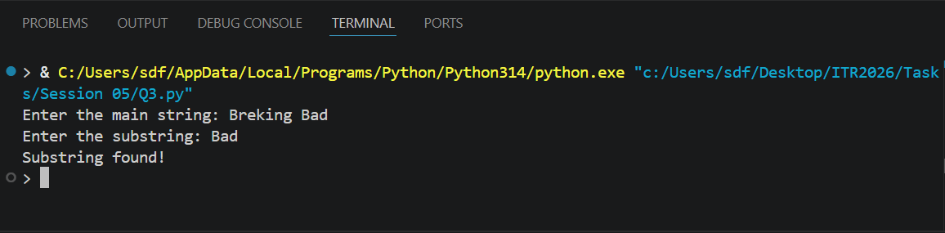
Q4. (len() Function)
Write a program that:
- Takes a string as input.
- Prints the length of the string using len().
- Prints the last character using len() (without using negative index).
- Prints the middle character if the length is odd.
Add comments on common mistakes with len().
Program Code:
# Take a string input from the user
input_string = input("Enter a string: ")

# Print the length of the string using len()

print("The length of the string is:", len(input_string))

# Print the last character using len() (without using negative index)
print("The last character is:", input_string[len(input_string) - 1])

# Print the middle character if the length is odd
if len(input_string) % 2 == 1:
middle_index = len(input_string) // 2
print("The middle character is:", input_string[middle_index])
else:
print("The string has an even length, so there is no single middle character.")

OUTPUT Screenshot:
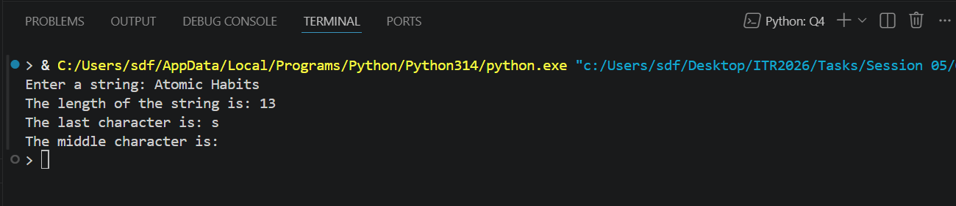
Q5. (range() - Basic Forms)
Write a program using for loop and range() to:
a) Print numbers from 0 to 10.
b) Print numbers from 5 to 15.
c) Print odd numbers from 1 to 21.
Explain the three forms of range() in comments.
Program Code:
# a) To print numbers from 0 to 10, we can use range() with a single argument which specifies the end of the range (exclusive). The start is by default 0 and the step is by default 1.
print("Numbers from 0 to 10:")
for i in range(11): # This will generate numbers from 0 to 10 (11 is exclusive)
print(i)

# b) To print numbers from 5 to 15, we can use range() with two arguments: the start and the end. The start is inclusive and the end is exclusive.
print("Numbers from 5 to 15:")
for i in range(5, 16): # This will generate numbers from 5 to 15 (16 is exclusive)
print(i)

# c) To print odd numbers from 1 to 21, we can use range() with three arguments: the start, the end, and the step. The step is set to 2 to get only odd numbers.
print("Odd numbers from 1 to 21:")
for i in range(1, 22, 2): # This will generate odd numbers from 1 to 21 (22 is exclusive)
print(i)

OUTPUT Screenshot:
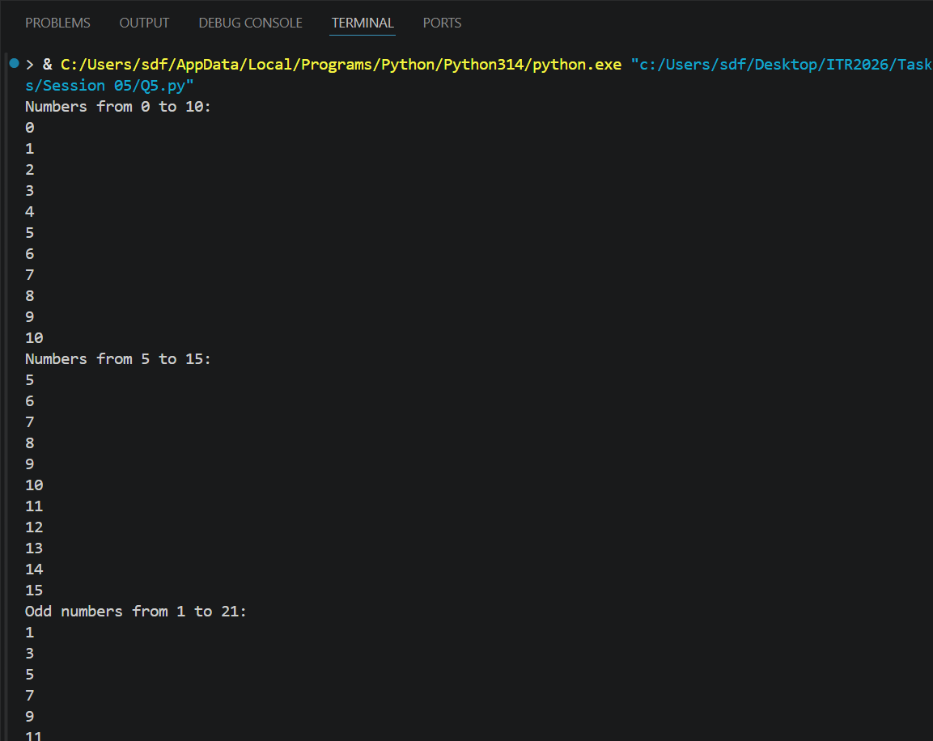
Task 6: Random Module
Write a program using the random module that: Generates and prints 5 random integers between 1 and 100. Generates and prints one random number between 50 and 150. Prints a random floating point number between 0 and 1. Use different functions from the random module.
Program Code:
import random

print("five random integers:")

for i in range(5):
print(random.randint(1, 100))
print("Random Number between 50 and 150:", random.randint(50, 150))
print("Random Floating Number:", random.random())

OUTPUT Screenshot:
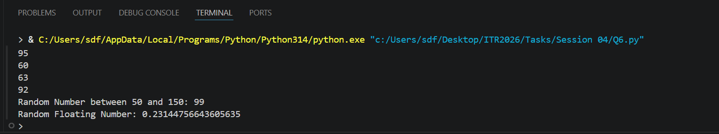
Task 7: Import Methods
Demonstrate different ways of importing modules: Import the entire math module using import math and use math.pow(2, 4). Import only sqrt from math using from math import sqrt. Import math with an alias as m and use m.factorial(5. Print the results with clear messages.
Program Code:
# Method 1
import math
print("Factorial of 5 =", math.factorial(5))
print("2^4 using math.pow =", math.pow(2, 4))

# Method 2
from math import sqrt
print("Square Root of 25 =", sqrt(25))

# Method 3
import math as m
print("Factorial of 5 =", m.factorial(5))

OUTPUT Screenshot:
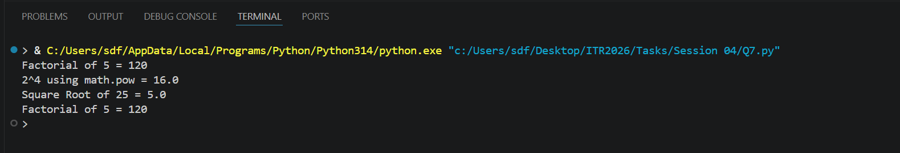
Task 8: Custom Module
Create a custom module file named mymodule.py that contains: A function greet(name) that prints "Hello [name], Welcome to Python Class!" A function calculate_power(base, exp) that returns base raised to exponent. Then write a main program that imports this module and uses both functions.
Program Code:
# Main program that imports and uses the custom module
import mymodule

# Using greet() function
mymodule.greet("Vaibhav")

# Using calculate_power() function
result = mymodule.calculate_power(2, 5)
print("2 raised to the power 5 =", result)

OUTPUT Screenshot:
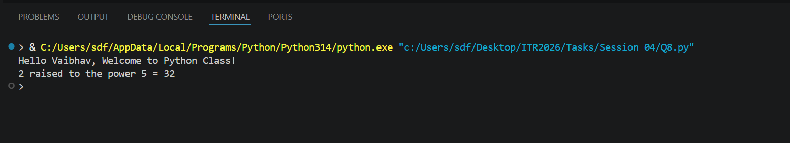
Task 9: (name == "main")
Write a program that: a) Creates a small function and demonstrates the use of if __name__ == "__main__": so that some code runs only when the file is executed directly.
Program Code:
def greet():
print("Welcome to Python Programming!")

if __name__ == "__main__":
print("This file is being run directly.")
greet()

OUTPUT Screenshot: 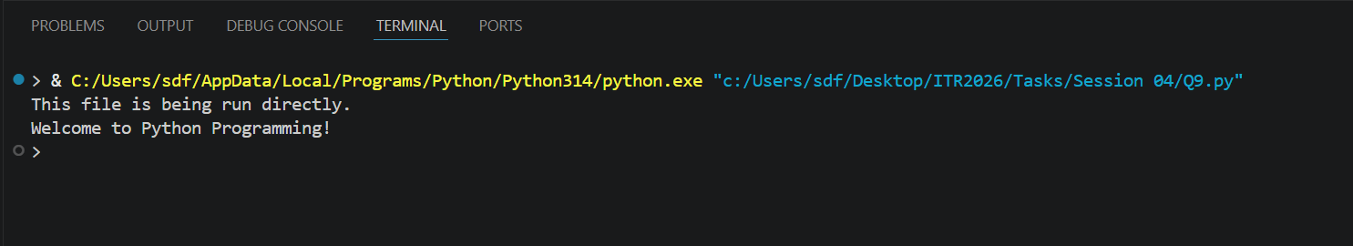

Task 10: Mini Project –
Combined Concepts) Create a Simple Math Utility Program using functions, lambda, loops and modules: Write the following: A lambda function to calculate square of a number. A normal function using math module to calculate power. Use a while loop to repeatedly ask the user for a number and choice Square / Power / Random Number). Use random module to generate a random number when chosen. Continue until the user chooses to exit. Use proper functions and comments. 3 Session 04 (AIML) - Assignment Questions
Program Code:
# Math Utility Program - Combined Concepts
import math
import random

# Lambda function for square
square = lambda x: x ** 2

# Function for power calculation
def calculate_power(base, exp):
return math.pow(base, exp)

# Function for random number
def generate_random():
return random.randint(1, 100)

# Main program
while True:
print("\n1. Square 2. Power 3. Random 4. Exit")
choice = input("Choice: ")

if choice == '1':
num = float(input("Enter number: "))
print(f"Square = {square(num)}")
elif choice == '2':
base = float(input("Base: "))
exp = float(input("Exponent: "))
print(f"Power = {calculate_power(base, exp)}")
elif choice == '3':
print(f"Random = {generate_random()}")
elif choice == '4':
print("Goodbye!")
break
else:
print("Invalid choice!")

OUTPUT Screenshot:
